Title (14 Bold)

Author Name 1 • Author Name 2 • Author Name 3 (12 Bold)

Affiliation Author 1 (11 Italic)
Affiliation Author 2 (11 Italic)

Abstract Insert abstract text directly after the heading. Leave an empty line after the abstract. Abstract should be one paragraph, with no indentation, and justified.

Keywords keyword 1 • keyword 2 • keyword 3

1 Section Title (Times, 11, Bold, Align Left)

When preparing your manuscript, please follow the instructions in this template. This template serves as a universal template for Special Issue Articles to be taken into consideration for publication in the Journal of Low Temperature Physics.
Insert an empty line after the section title. Indent at the start of each paragraph after the first paragraph of the section, which is not indented. For this special issue there is no page limit.

2 Section Title

2.1 Equations (Times, 11, Align Left)

Place equations in the text and number them. You can use the Word Equation Editor or MathType to write your equations.
(1)
When referring to equations please use parentheses and the number of the equation as follows: Eq. (1).

2.2 Figures

When inserting figures:
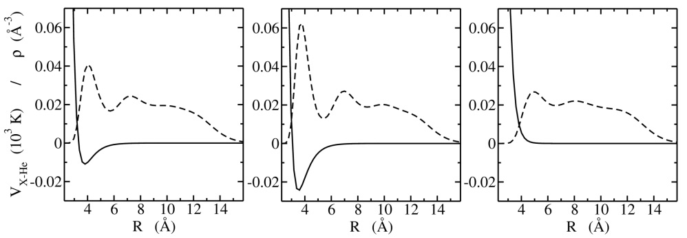
Fig. 1 Insert the figure caption directly after the header. Use the words Top, Bottom, Left, and Right (in italics) to denote the sub figures being described. Additional annotation should also be in italics, e.g., solid symbols, open symbols, red, dashed line, etc. If including color figures, please supply a B&W or greyscale figure as well for print and include the following statement at the end of your caption: (Color figure online)

Leave an empty line after the Figure caption. When referring to figures in the text, please do so as follows: Fig. 1.

3 Section Title

3.1 References

Regarding references: please see the example bibliography below. Please include DOI numbers wherever possible. Please number your references in order of appearance in the text. Citations should be with square brackets as follows [1], [2,3] or [4-7].
Please use the commonly used and accepted journal abbreviation whenever possible. For example, the Journal of Low Temperature Physics is J. Low Temp. Phys.
When citing articles that shall appear in the same special issue, please do the following. During the review stage you will be asked to cite the article as A. Name, J. Low Temp. Phys. This Special Issue (year). Upon acceptance of the article and receiving the proofs, you will be requested to update the references and replace “This special issue” with the full citation and DOI number. Articles that have been accepted and published online (on SpringerLink) will immediately have a DOI number even if they are not assigned to an issue yet. When citing articles that appeared in previous special issues of this journal, please use the standard citation and include the DOI number (see first example below).

Acknowledgements (Optional) Please enter text directly after the header.

References

- E. Livne, A. Eyal, O. Scaly, E. Polturak, J Low Temp Phys 180, 185–199 (2015), DOI:10.1007/s10909-015-1308-8
- J.A. Nissen, E. Bodegom, L.C. Brodie, J.S. Semura, Phys. Rev. B 40, 6617 (1989)
- H.J. Maris, S. Balibar, M.S. Pettersen, J. Low Temp. Phys. 93, 1069 (1993), DOI …
- H.J. Maris, J. Low Temp. Phys. 98, 403 (1995), DOI
- G.V. Sin’ko, N.A. Smirnov, J. Phys. Condens. Matter 14, 6989 (2002), DOI …
- G. Grimvall et al., Rev. Mod. Phys. 84, 945 (2012), DOI
- H.J. Maris, Phys. Rev. Lett. 66, 45 (1991), DOI …
- R. Barnett, P. Reynolds, W.A. Lester Jr, J. Comput. Phys. 96, 258 (1991), DOI
- R.A. Aziz, F.R.W. McCourt, C.C.K. Wong, Mol. Phys. 61, 1487 (1987), DOI …
- C. Cazorla, J. Boronat, J. Phys. Condens. Matter 20, 015223 (2008),

